***Manav Rachna International Institute of Research and Studies***

***School of Computer Applications***

***Department of Computer Applications***

| ***Submitted By*** | |
| --- | --- |
| ***Student Name*** | Hansika |
| ***Roll No*** | ***24/SCA/BCA(AI&ML)/022*** |
| ***Programme*** | ***BCA (AI&ML)*** |
| ***Semester*** | ***1st Semester*** |
| ***Section/Group*** | ***I B*** |
| ***Department*** | ***Computer Applications*** |
| ***Batch*** | ***2024-2028*** |
|  | |
| ***Submitted To*** | |
| ***Faculty Name*** | ***Mrs. Sakshi*** |

 **SCHOOL OF COMPUTER APPLICATIONS**

**INDEX**

|  |  |  |
| --- | --- | --- |
| S.No | Experiment | Remark |
|  | Create a simple HTML page using basic tags. |  |
|  | Create a web page that displays your name to the screen. |  |
|  | Create a web page and show the output from 1 to 10 in separate lines. |  |
|  | Create a web page and show the output from 1 to 10 in separate lines, each number being in different color. |  |
|  | How do I make a picture as a background on my web pages? |  |
|  | Create a web page to print a paragraph with 4-5 sentences, each sentence shall have a different font. |  |
|  | Write HTML code to print a paragraph that is description of a book, it shall include the title of the book, its author name; name and title should be underlined and all adjectives shall be bold and Italics. |  |
|  | Write HTML code to print your name using Heading tag, every letter shall be of different heading size. |  |
|  | Write HTML code to print the sequence of numbers 1-20. Each number shall be in different line with number 2 next to it as subscript, an equal sign and the result. |  |
|  | Write HTML code to display an image with border of size with width 200, height 200 pixels, leaving Hspace and Vspace of your choice with image hanging in the right side on the screen. |  |
|  | Write HTML code to create a web page with heading. The heading shall be displayed at the top-center of the page and the image shall be at the centre, just below the heading. |  |
|  | Write HTML code using Multimedia tags. |  |
|  | Create a Table using Rowspan and Colspan taking example of student Record. |  |
|  | Write HTML code using table tag <table> and cellpadding and cell spacing as its attributes. |  |
|  | Create unordered, ordered and definition Lists taking example of your subjects in MCA IST, IInd and IIIrd Semester. |  |
|  | Write HTML code using <frameset> and <frame> tag with all its attributes |  |
|  | Write HTML code to design a form in HTML using controls and buttons such as Textbox, Text area, password, submit button, browse button, drop-down menu |  |
|  | Write HTML code to design a Registration Form in HTML. |  |
|  | Write HTML code to design a student admission Form in HTML. |  |
|  | Create a proper home page of your own using any components and styles. |  |
|  | Write HTML code for including Local hyperlinking in a web page. |  |
|  | Write HTML code for including Inter hyperlinking in a web page. |  |
|  | Write HTML code for including External hyperlinking in a web page. |  |
|  | Write code to show External CSS with HTML code |  |
|  | Write code to show Internal CSS with HTML code. |  |
|  | Write code to show Inline CSS with HTML code. |  |
|  | Write a program to add two numbers using form in JavaScript. |  |
|  | Write a program in JavaScript to swap two images using on mouseover event. |  |
|  | Write a simple JavaScript program to sort an array |  |
|  | Write a JavaScript program to take as input three numbers from the user. Find the minimum and maximum of the three numbers. Print the following output in BOLD in the following format:  MINIMUM =        MAXIMUM = |  |

Question-1

Create a simple HTML page using basic tags

Input:

<html>

<head>

<title></title>

</head>

<body>

<h1>How to create webpage</h1>

<p>It’s easy amd fun </p>

</body>

</html>

Output:

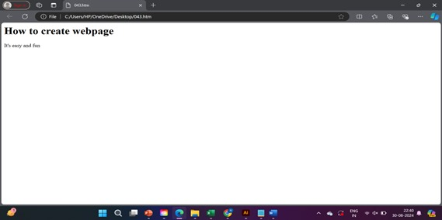

Question-2

Create a webpage that displays your name to the screen

Input:

<html>

<head>

<title>My name</title>

</head>

<body>

<p>Hansika Katyal </p>

</body>

<html>

Output:

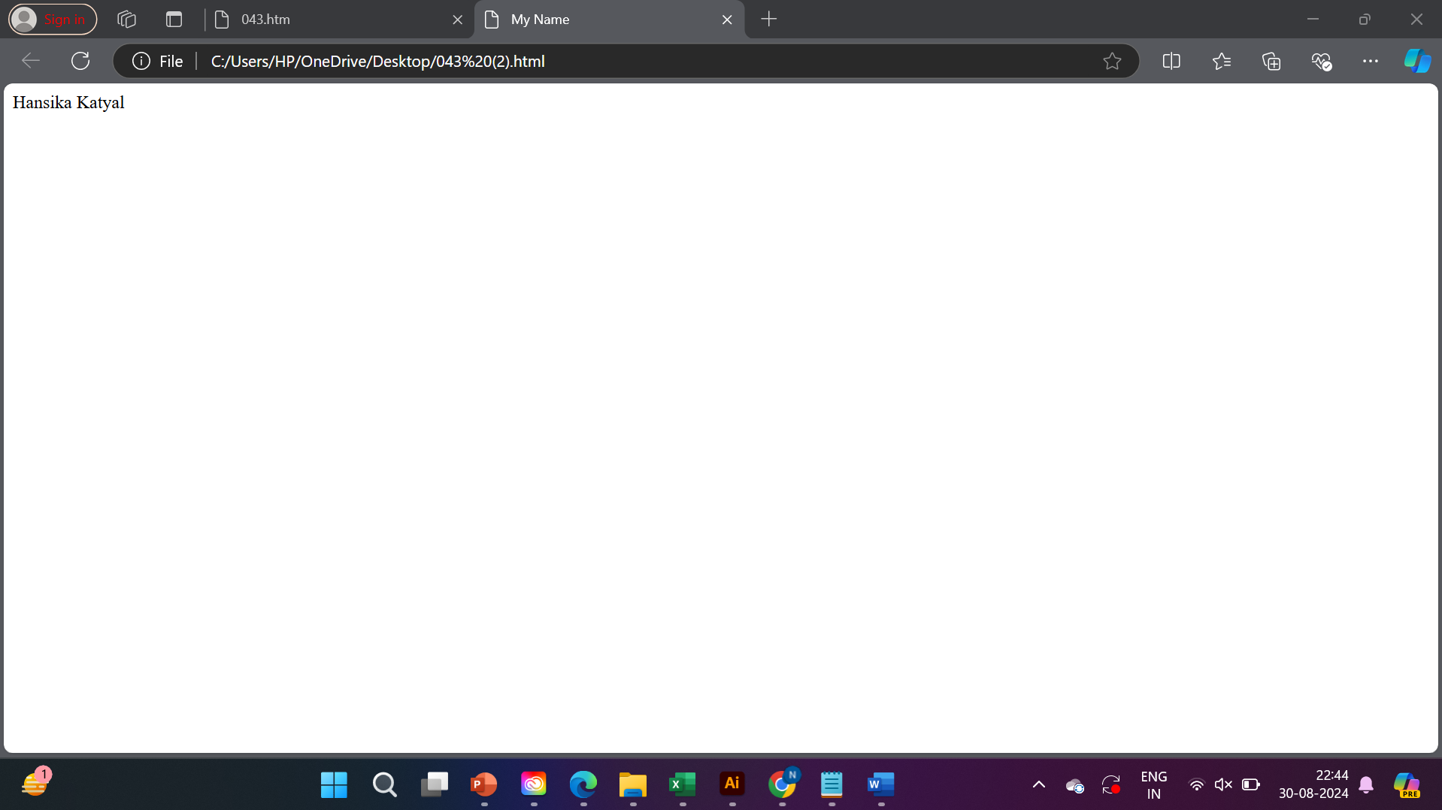

Question-3

Create a web page and show the output from 1 to 10 in separate lines

Input:

<html>

<head>

<title>Numbers</title>

</head>

<body>

1<br>

2<br>

3<br>

4<br>

5<br>

6<br>

7<br>

8<br>

9<br>

10<br>

</body>

</html>

Output:

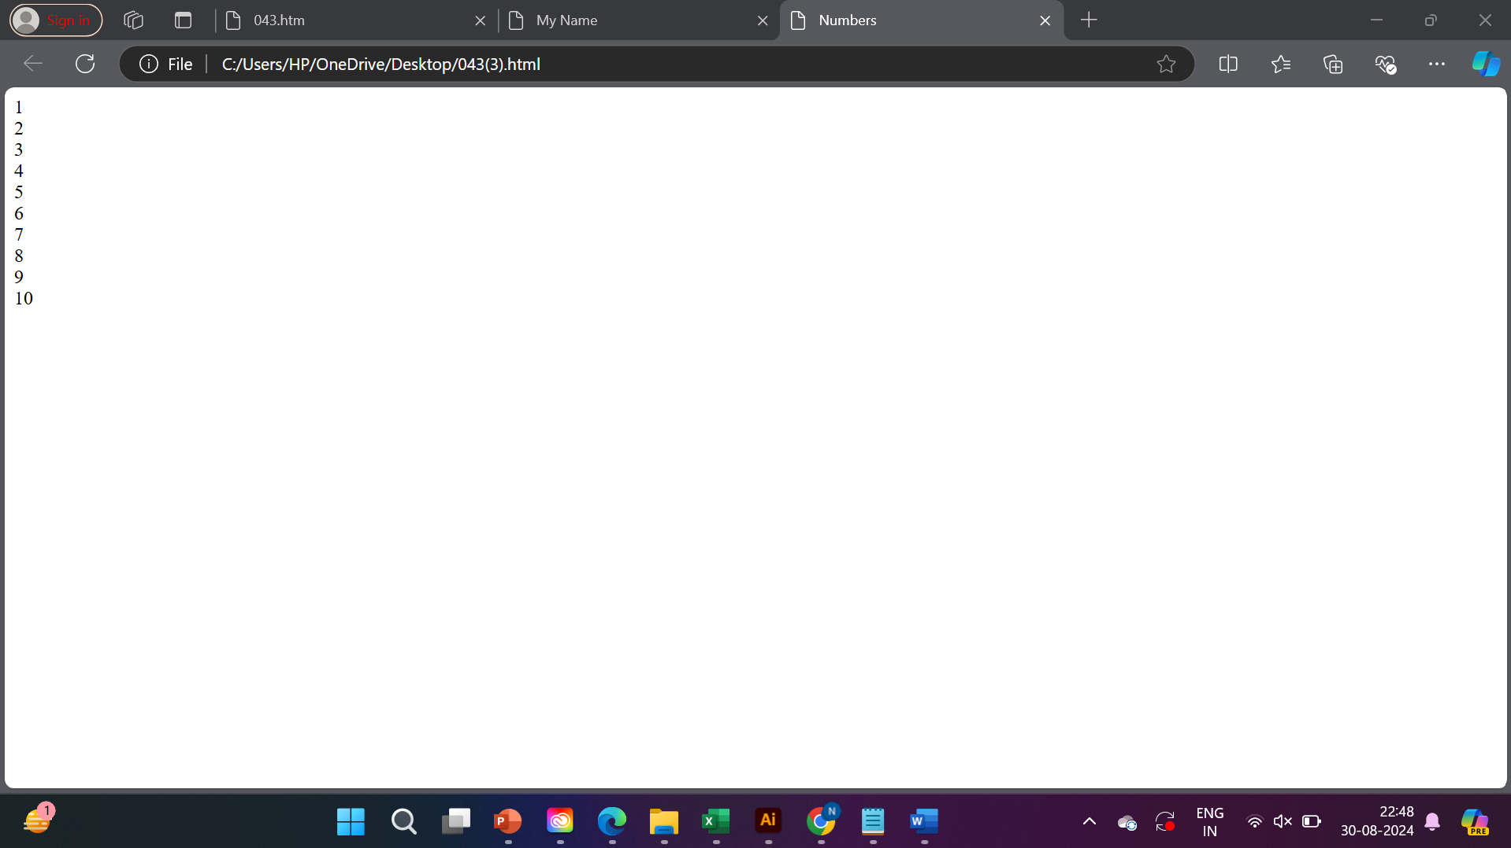

Question-4

Create a web page and show the output from 1 to 10 in separate line,each number being in different colour

Input:

<html>

<head>

<title>Numbers</title>

</head>

<body>

<h1><p align=”centre”>

<font color=”#20fc03”>1<br></font>

<font color=”#03fce3”>2<br></font>

<font color=”#0377fc”>3<br></font>

<font color=”27e653”>4<br></font>

<font color=”d9401a”>5<br></font>

<font color=”453a3a”>6<br></font>

<font color=”b89bc4”>7<br></font>

<font color=”633d46”>8<br></font>

<font color=”f70000”>9<br></font>

<font color=”000099”>10<br></font>

</p></h1>

</body>

</html>

Output:

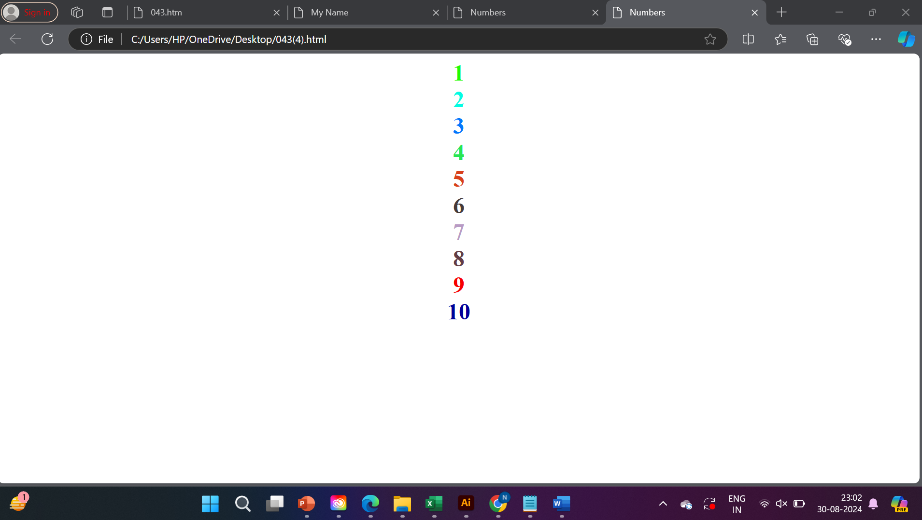

Question – 5

How to I make a picture as abackground on my web page?

Input:

<html>

<head>

<title>How to add an image as background image of a web page?</title>

</head>

<body><img src=”JPEG File (.jpeg)”>

<h1>How to add an image as background image of a web page?</h1>

</body>

</html>

Output:

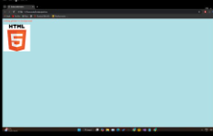

Question-6

Create a web page to print paragraph with 4-5 sentences,each sentence shall have a different font

Input:

<html>

<body>

<p>

<font face=”Arial”>

A web page is a document on the web that is accessed in a web browser. A website typically consists of many web pages linked together under a common domain name. The term “web page”is thus a methapor of paper pages bound together into a book.

</font>

<font face=”Times New Roman”>

Each web page is identified by a distinct uniform resource locator(URL). When the user inputs a URL into their web browser, the browser retrievs the necessary content from a web server and then transforms it into an interactive visual representation on the user’s screen.

</font>

<font face=”Verdana”>

If the user clicks or taps a link, the browser repeats this process to load the new URL, which could to be part of the current website or a different one. The browser has features, such as the address bar, that indicate which page is displayed.

</font>

<font face=”Helvetica”>

A web page is a structured document. The core element is a text file written in the HyperText Markup Language(HTML). This specifies the content of the page, including images and video. Cascading Style Sheets(CSS) specify the presentation of the page. CSS rules can be in separate text files or embedded within the HTML file.

</font>

</p>

</body>

</html>

Output:

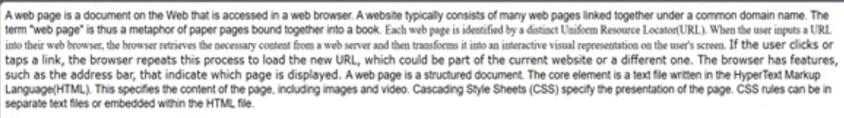

Question – 7

Write HTML code to print a paragraph that is description of a book, it shall include the title of the book, its author name; name and title should be undrlined and all adjectives shall be bold and italics

Input:

<html>

<head>

<title>Student Information</title>

</head>

<body style="background-color:light green;">

<p>Book name - <b><u><i>Harry Potter and the Philosopher's stone</b></u></i>Author name-<b><u><i>J.K.Rowling</b></u></i></p>

</body>

</html>

Output:

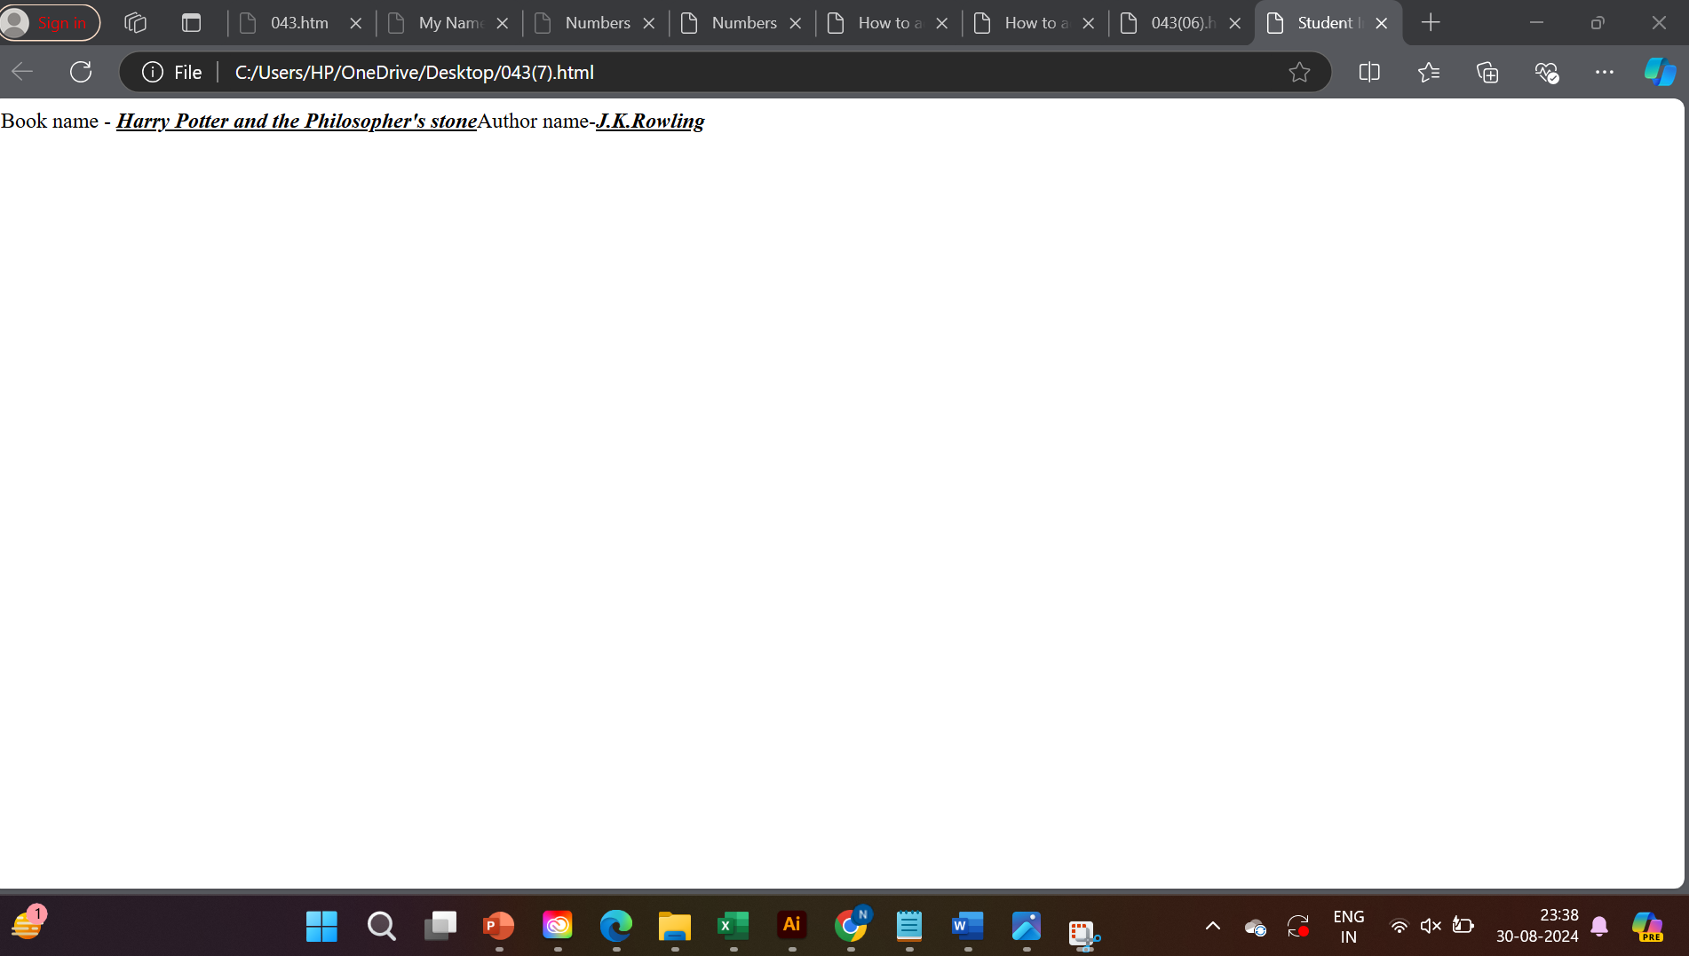

Question -8

Write HTML code to print your name using Heading tag, every letter shall be of different heading size

Input:

<html>

<head>

<title>Heading tag</title>

</head>

<body>

<h1>H</h1>

<h2>A</h2>

<h3>N</h3>

<h4>S</h4>

<h5>I</h5>

<h6>K</h6>

<h7>A</h7>

</body>

</html>

Output:

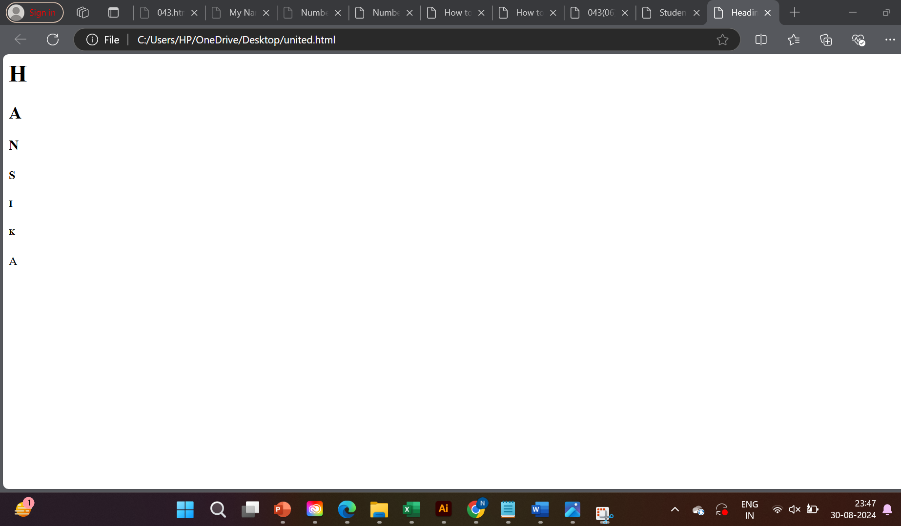

Question -9

Write HTML code to print the sequence of number 1-20. Each number shallbe in different line with number2 next to it as subscript, an equal sign and the result.

Input:

<html>

<head>

<title>Heading Tag</title>

</head>

<body>

<p>1<sub>2</sub>=2</p>

<p>2<sub>2</sub>=4</p>

<p>3<sub>2</sub>=6</p>

<p>4<sub>2</sub>=8</p>

<p>5<sub>2</sub>=10</p>

<p>6<sub>2</sub>=12</p>

<p>7<sub>2</sub>=14</p>

<p>8<sub>2</sub>=16</p>

<p>9<sub>2</sub>=18</p>

<p>10<sub>2</sub>=20</p>

<p>11<sub>2</sub>=22</p>

<p>12<sub>2</sub>=24</p>

<p>13<sub>2</sub>=26</p>

<p>14<sub>2</sub>=28</p>

<p>15<sub>2</sub>=30</p>

<p>16<sub>2</sub>=32</p>

<p>17<sub>2</sub>=34</p>

<p>18<sub>2</sub>=36</p>

<p>19<sub>2</sub>=38</p>

<p>20<sub>2</sub>=40</p>

</body>

</html>

Output:

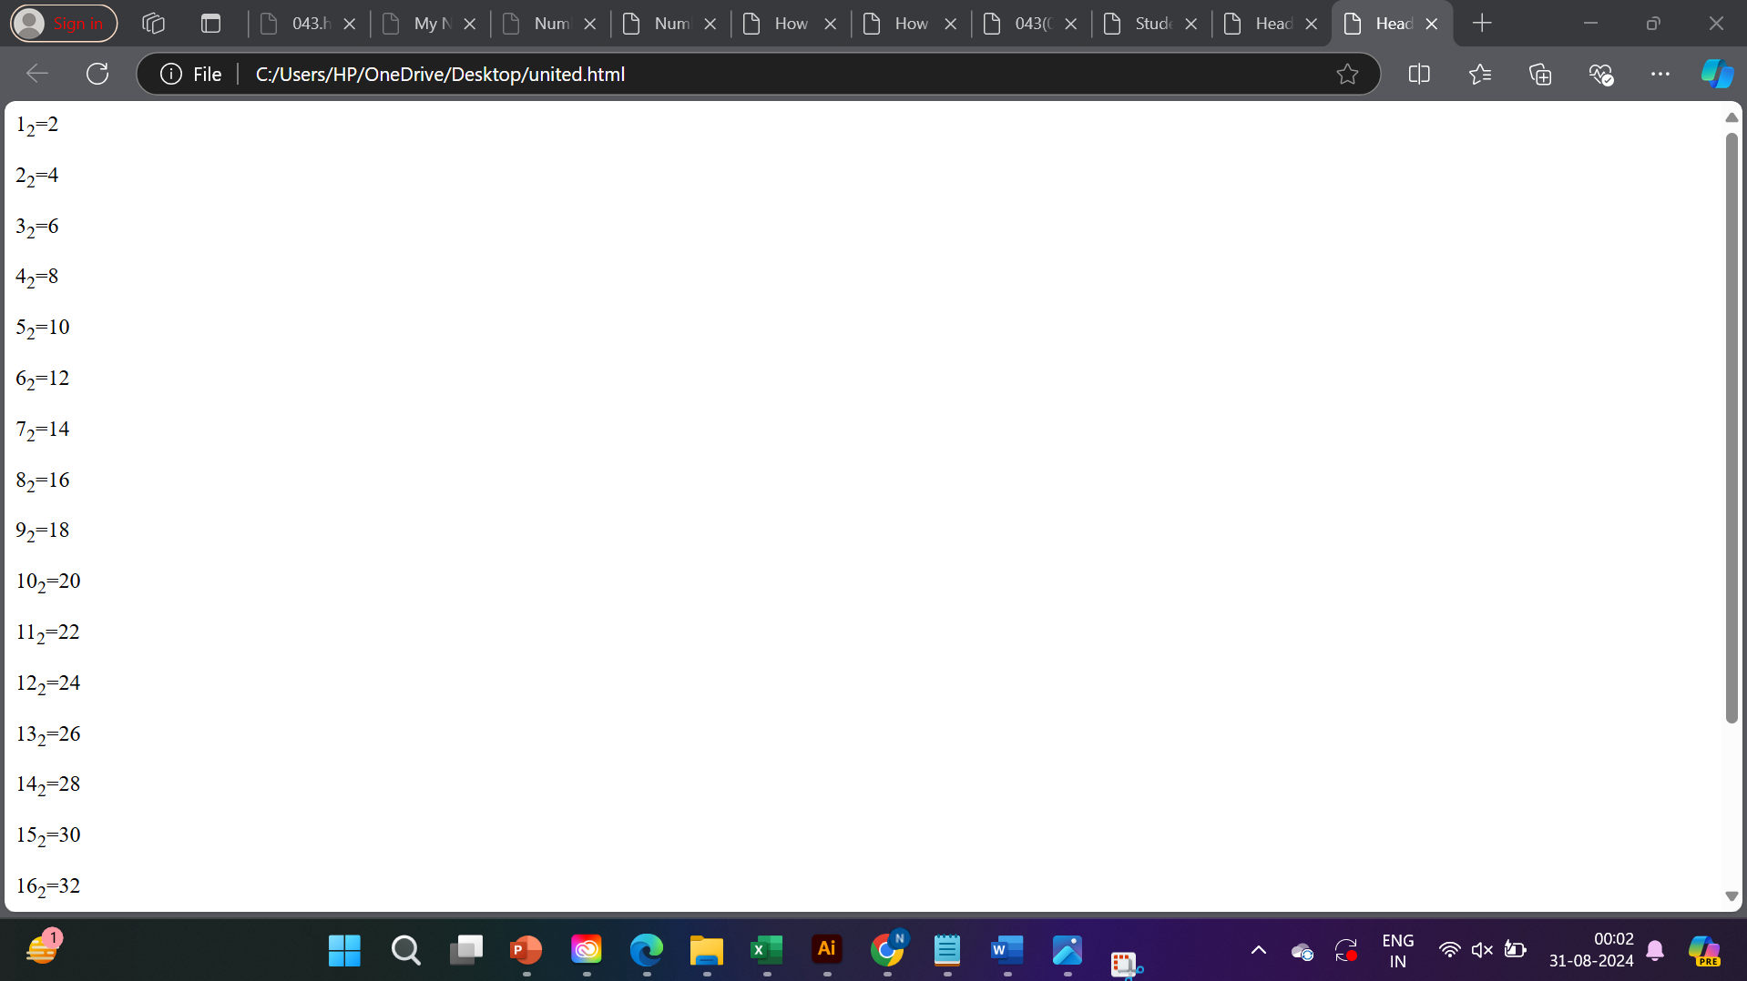

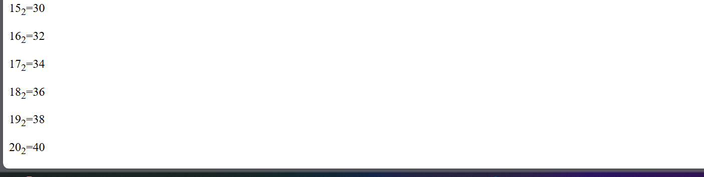

Question – 10

Write HTML code to display an image with border of size with width 200, height 200 pixels, leaving Hspace and Vspace of your choice with image hanging in the right side on the screen.

Input:

<html>

<head>

<title>Image with Width Attribute</title>

</head>

<body>

<h1>Image of a Tri-colored Tabby Cat (Width: 612px)

</h1>

<img src ="https://media.istockphoto.com/id/1198100351/photo/portrait-of-beautiful-and-fluffy-tri-colored-tabby-cat-at-home-natural-light.jpg?s=612x612&w=0&k=20&c=4p4gjq48aYnD9jNQf9yazpGCpn620btJ5H8VJX3OElo=" width="612" alt="Tri-colored Tabby Cat">

</body>

</html>

Output:

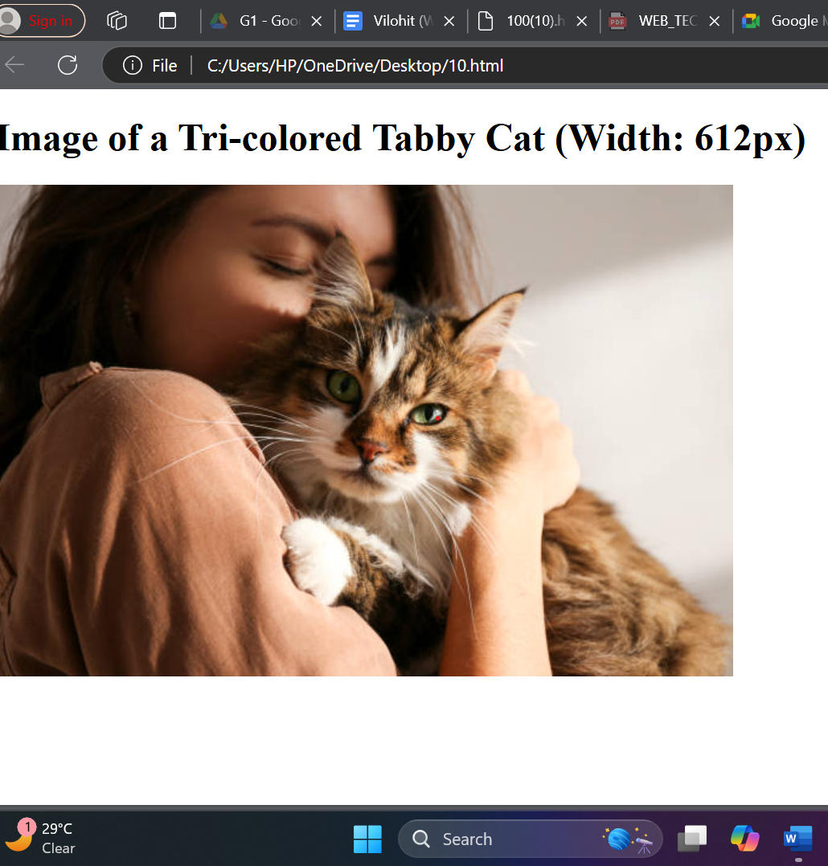

Question 11

Write HTML code to create a web page with heading. The heading shall be displayed at the top-center of the page and the image shall be at the centre, just below the heading.

Input :

<html>

<head>web page </head>

<body>

<center><h1>VIRAT KOHLI</h1></center>

<center><img src ="https://im.rediff.com/cricket/2023/jan/17kohli1.jpg"height="300"width="300"></center></body>

</html>

Output:

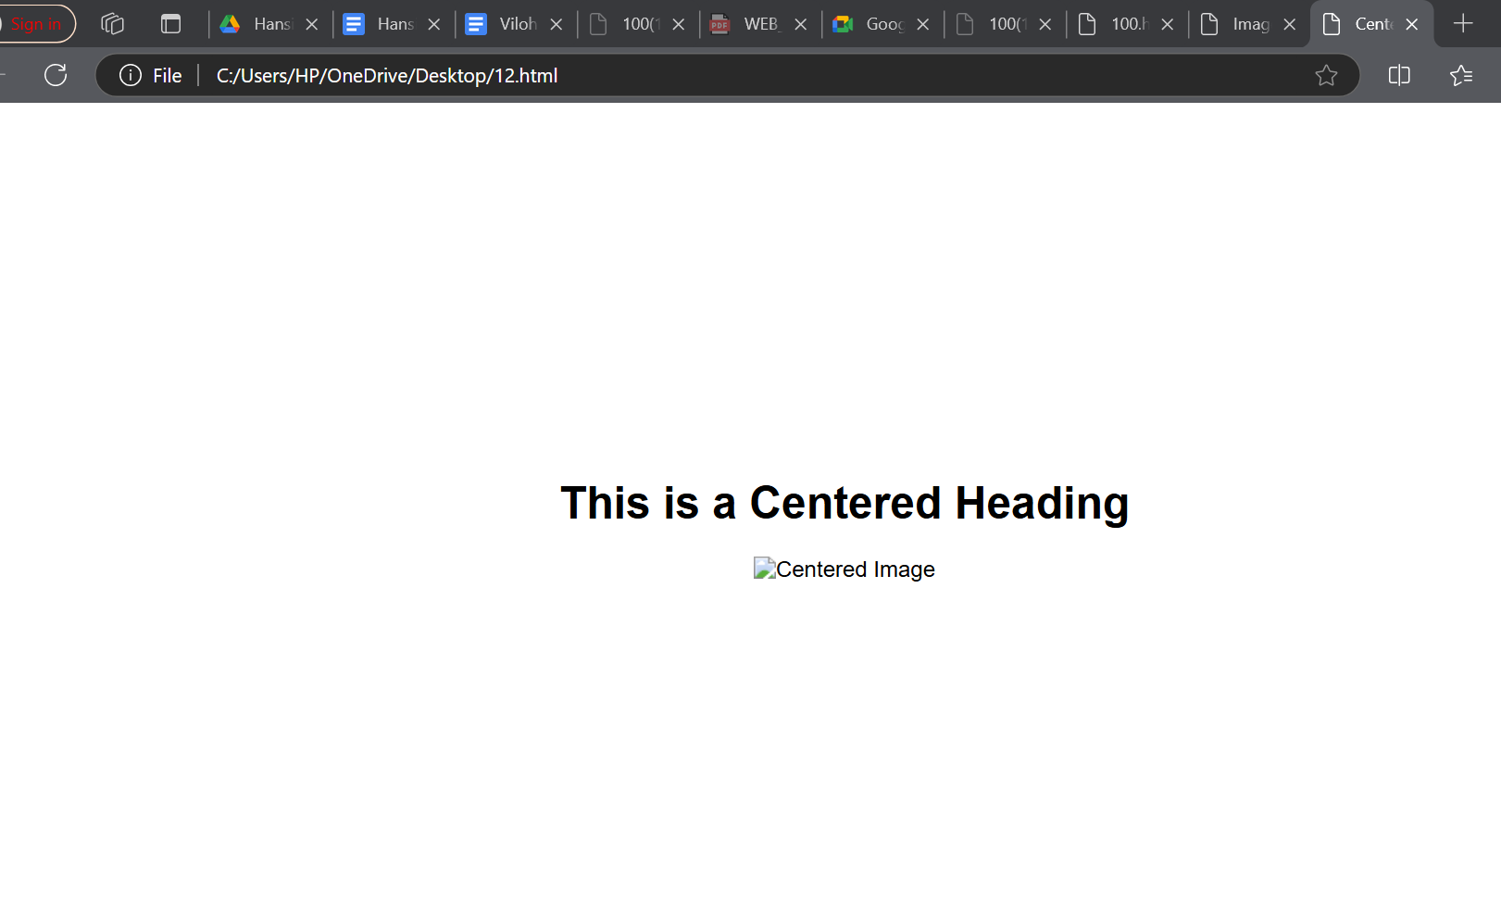

Question-12

Write HTML code using Multimedia tags.

Input:

<html>

<head>

<title>Multimedia Example</title>

</head>

<body>

<h2>Image Example</h2>

<img src="C:\Users\HP\OneDrive\Desktop\scenry" alt="Beautiful Scenery" width="500">

<!-- Embedding a video -->

<h2>Video Example</h2>

<video width="500" controls>

<source src="C:\Users\HP\OneDrive\Desktop\scenery video" type="video/mp4">

</video>

<!-- Embedding audio -->

<h2>Audio Example</h2>

<audio controls>

<source src="sample-audio.mp3" type="audio/mpeg"

</audio>

</body>

</html>

Output:

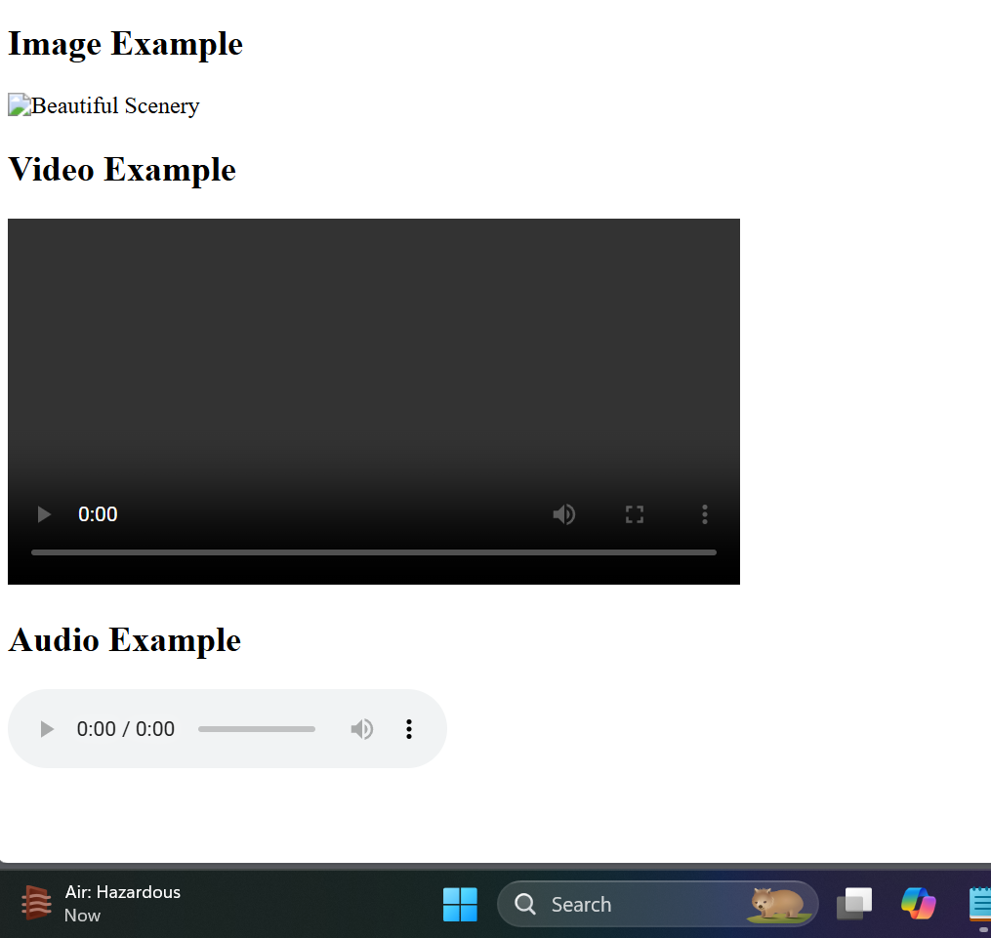

Question-13

Create a Table using Rowspan and Colspan taking example of student Record.

Input:

<html>

<head>

<title>Student Record</title>

<style>

table {

width: 80%;

border-collapse: collapse;

margin: 20px auto;

}

th, td {

border: 1px solid #000;

padding: 8px;

text-align: center;

}

</style>

</head>

<body>

<table>

<tr>

<th rowspan="2">Student ID</th>

<th rowspan="2">Name</th>

<th colspan="3">Subjects</th>

</tr>

<tr>

<th>Math</th>

<th>Science</th>

<th>English</th>

</tr>

<tr>

<td>1</td>

<td>Riya</td>

<td>85</td>

<td>90</td>

<td>78</td>

</tr>

<tr>

<td>2</td>

<td>Priya</td>

<td>88</td>

<td>92</td>

<td>80</td>

</tr>

</table>

</body>

</html>

Output:

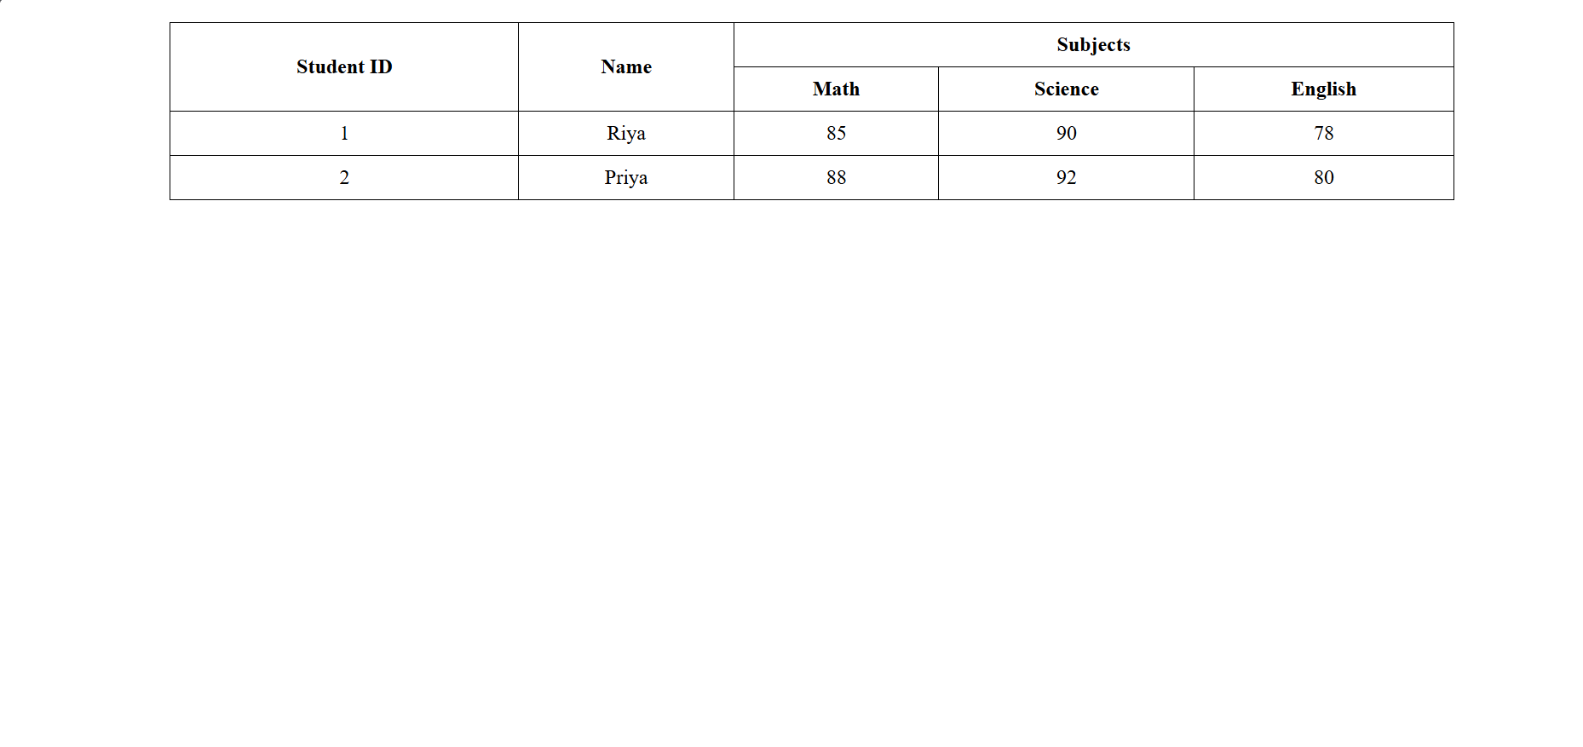

Question-14

Write HTML code using table tag <table> and cellpadding and cellspacing as its attributes.

Input:

<html>

<head>

<title>Student Record Table</title>

<style>

table {

border: 1px solid #000;

margin: 20px auto;

border-collapse: collapse;

}

th, td {

border: 1px solid #000;

padding: 10px;

text-align: center;

}

</style>

</head>

<body>

<table cellpadding="10" cellspacing="5">

<tr>

<th>Student ID</th>

<th>Name</th>

<th>Math</th>

<th>Science</th>

<th>English</th>

</tr>

<tr>

<td>1</td>

<td>Riya</td>

<td>85</td>

<td>90</td>

<td>78</td>

</tr>

<tr>

<td>2</td>

<td>Zaen</td>

<td>88</td>

<td>92</td>

<td>80</td>

</tr>

</table>

</body>

</html>

Output:

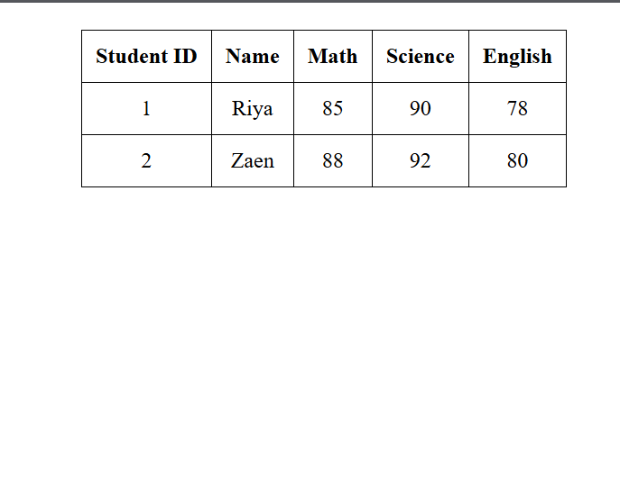

Question-15

Create unordered, ordered and definition Lists taking example of your subjects in MCA IST, IInd and IIIrd Semester.

Input:

<html>

<head>

<title>MCA Subjects</title>

</head>

<body>

<h1>MCA IST Subjects</h1>

<!-- Unordered List -->

<h2>IInd Semester Subjects</h2>

<ul>

<li>Database Management Systems</li>

<li>Data Structures and Algorithms</li>

<li>Software Engineering</li>

<li>Web Technologies</li>

</ul>

<!-- Ordered List -->

<h2>IIIrd Semester Subjects</h2>

<ol>

<li>Operating Systems</li>

<li>Computer Networks</li>

<li>Mobile Application Development</li>

<li>Artificial Intelligence</li>

</ol>

<!-- Definition List -->

<h2>Subject Definitions</h2>

<dl>

<dt>Database Management Systems</dt>

<dd>A system for creating and managing databases.</dd>

<dt>Data Structures and Algorithms</dt>

<dd>The study of data organization and the algorithms that operate on them.</dd>

<dt>Software Engineering</dt>

<dd>The application of engineering principles to software development.</dd>

<dt>Web Technologies</dt>

<dd>Technologies used for developing web applications.</dd>

<dt>Operating Systems</dt>

<dd>The software that manages computer hardware and software resources.</dd>

<dt>Computer Networks</dt>

<dd>The study of interconnecting computers to share resources.</dd>

<dt>Mobile Application Development</dt>

<dd>The process of creating software applications for mobile devices.</dd>

<dt>Artificial Intelligence</dt>

<dd>The simulation of human intelligence processes by machines.</dd>

</dl>

</body>

</html>

Output:

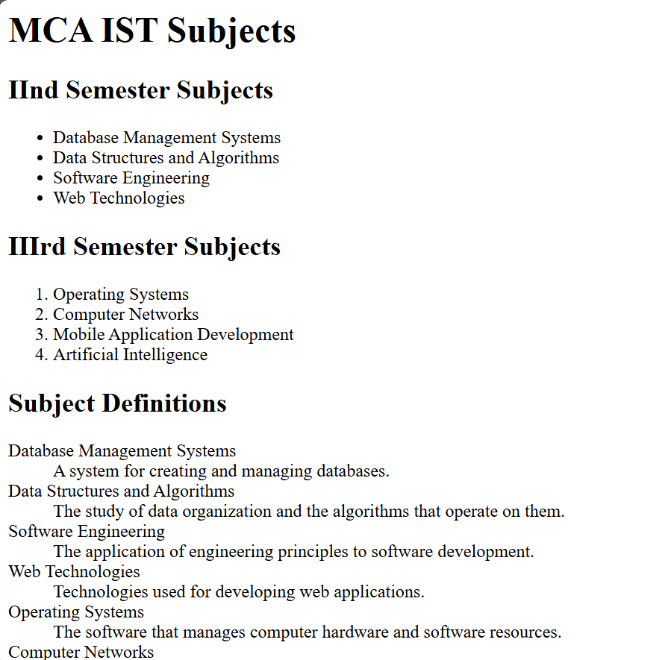

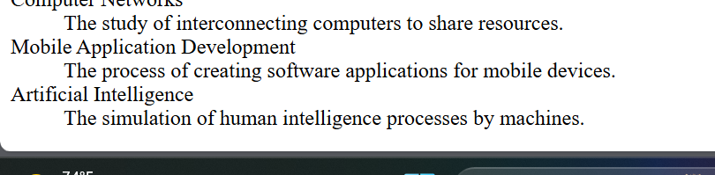

Question-16

Write HTML code using <frameset> and <frame> tag with all its attributes

Input:

<html>

<head>

<title>Frameset Example</title>

</head>

<frameset rows="50%,50%" border="2" frameborder="yes" framespacing="5">

<frame src="header.html" name="header" scrolling="no" noresize>

<frame src="content.html" name="content" scrolling="yes">

</frameset>

<noframes>

<body>

<p>Your browser does not support frames. Please consider updating your browser.</p>

</body>

</noframes>

</html>

Output:

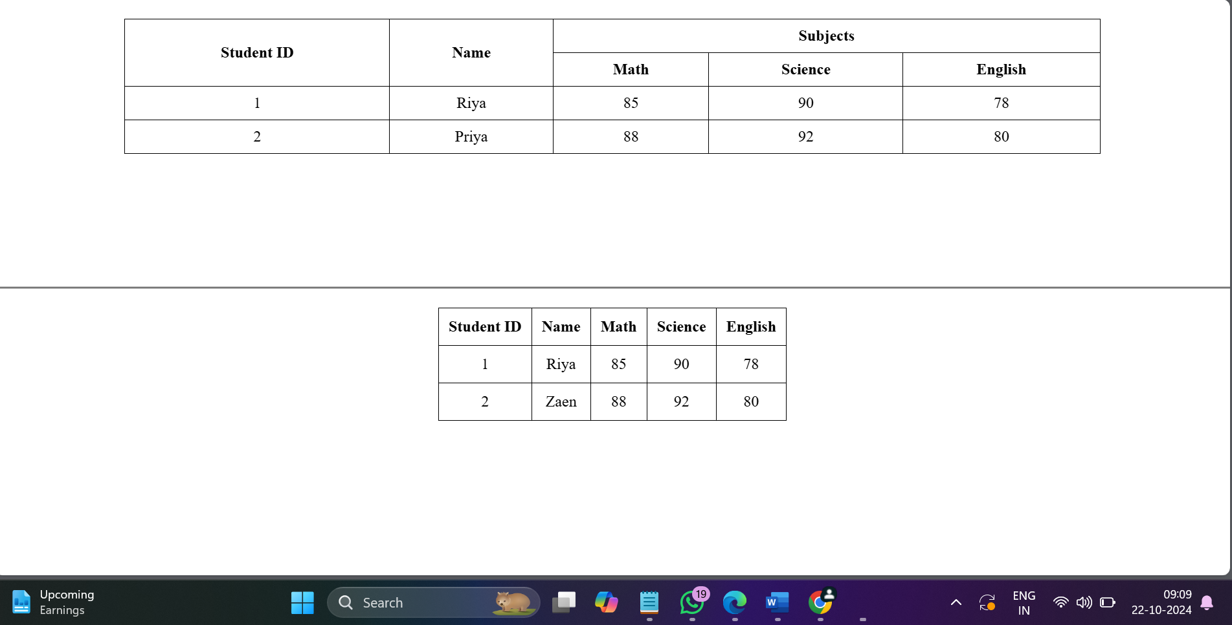

Question-17

Write HTML code to design a form in HTML using controls and buttons such as Teaxtbox, Textarea

Input:

<html>

<head>

<title>Sample Form</title>

<style>

body {

font-family: Arial, sans-serif;

margin: 20px;

}

form {

max-width: 400px;

margin: auto;

}

label {

display: block;

margin-top: 10px;

}

input, textarea, select {

width: 100%;

padding: 8px;

margin-top: 5px;

box-sizing: border-box;

}

button {

margin-top: 10px;

padding: 10px;

background-color: #4CAF50;

color: white;

border: none;

cursor: pointer;

}

button:hover {

background-color: #45a049;

}

</style>

</head>

<body>

<h1>Feedback Form</h1>

<form action="/submit" method="post">

<label for="name">Name:</label>

<input type="text" id="name" name="name" \>

<label for="email">Email:</label>

<input type="email" id="email" name="email" \>

<label for="feedback">Feedback:</label>

<textarea id="feedback" name="feedback" rows="4" ></textarea>

<label>Preferred Contact Method:</label>

<input type="radio" id="phone" name="contact" value="phone">

<label for="phone">Phone</label>

<input type="radio" id="email_contact" name="contact" value="email" checked>

<label for="email_contact">Email</label>

<label>Subscribe to Newsletter:</label>

<input type="checkbox" id="subscribe" name="subscribe" value="yes">

<label for="subscribe">Yes, I want to receive updates</label>

<button type="submit">Submit</button>

</form>

</body>

</html>

Output:

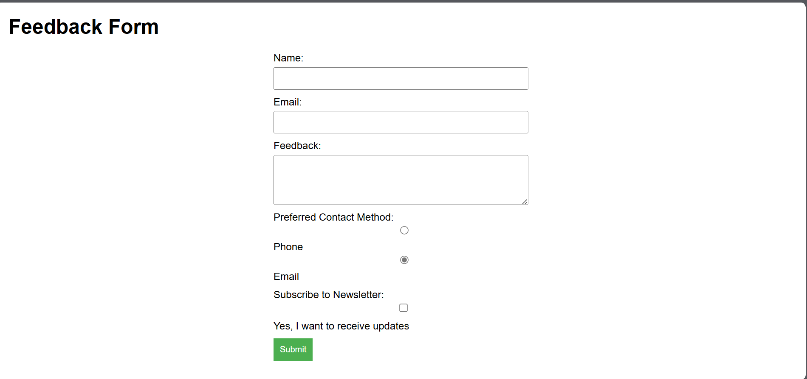

Question-18

Write HTML code to design a Registration Form in HTML.

Input:

<html>

<head>

<title>Registration Form</title>

<style>

body {

font-family: Arial;

margin: 20px;

background-color:White;

}

form {

max-width: 500px;

margin: auto;

background: white;

padding: 20px;

border-radius: 5px;

box-shadow: 0 0 10px

}

label {

display: block;

margin-top: 10px;

}

input, select, textarea {

width: 100%;

padding: 8px;

margin-top: 5px;

box-sizing: border-box;

}

button {

margin-top: 10px;

padding: 10px;

background-color:Black;

color: white;

border: none;

cursor: pointer;

width: 100%;

}

button:hover {

background-color: Blue;

}

</style>

</head>

<body>

<h1>Registration Form</h1>

<form action="/submit" method="post">

<label for="username">Username:</label>

<input type="text" id="username" name="username" required>

<label for="email">Email:</label>

<input type="email" id="email" name="email" required>

<label for="password">Password:</label>

<input type="password" id="password" name="password" required>

<label for="confirm-password">Confirm Password:</label>

<input type="password" id="confirm-password" name="confirm-password" required>

<label for="dob">Date of Birth:</label>

<input type="date" id="dob" name="dob" required>

<label for="gender">Gender:</label>

<select id="gender" name="gender" required>

<option value="">Select Gender</option>

<option value="male">Male</option>

<option value="female">Female</option>

<option value="other">Other</option>

</select>

<label for="address">Address:</label>

<textarea id="address" name="address" rows="4" required></textarea>

<label for="phone">Phone Number:</label>

<input type="tel" id="phone" name="phone" required>

<button type="submit">Register</button>

</form>

</body>

</html>

Output:

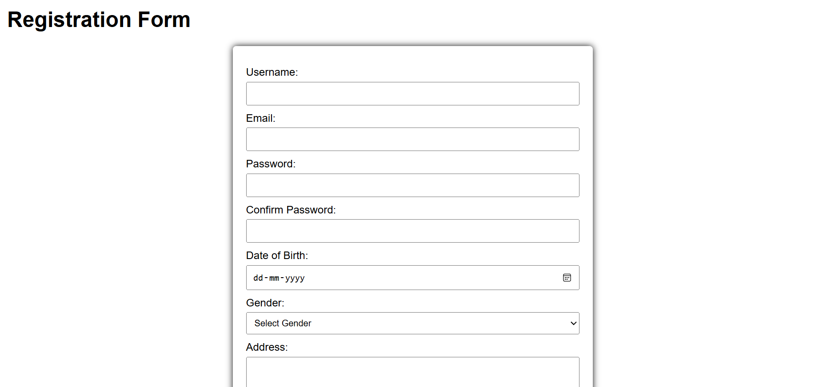

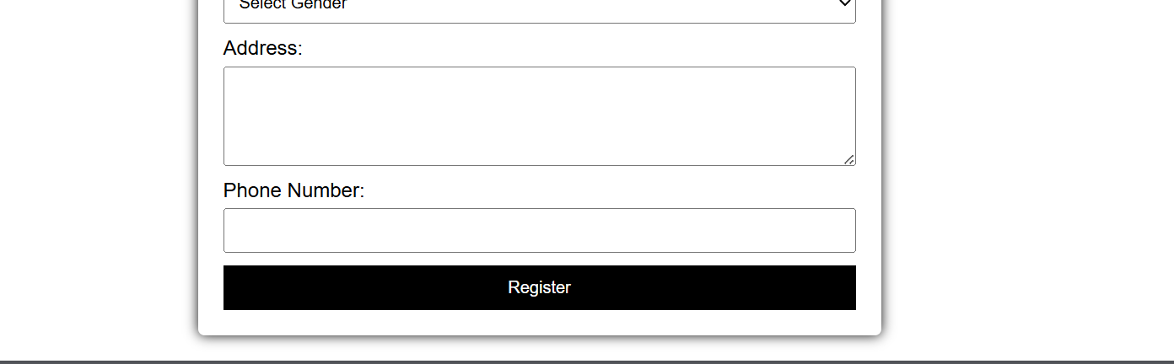

Question-19

Write HTML code to design a student admission Form in HTML.

Input:

<html>

<head>

<title>Student Admission Form</title>

<style>

body {

font-family: Arial;

margin: 20px;

background-color: Green;

}

form {

max-width: 600px;

margin: auto;

background: white;

padding: 20px;

border-radius: 5px;

box-shadow: 0 0 10px ;

}

label {

display: block;

margin-top: 10px;

}

input, select, textarea {

width: 100%;

padding: 8px;

margin-top: 5px;

box-sizing: border-box;

}

button {

margin-top: 10px;

padding: 10px;

background-color: White;

color: white;

border: none;

cursor: pointer;

width: 100%;

}

button:hover {

background-color:Red;

}

</style>

</head>

<body>

<h1>Student Admission Form</h1>

<form action="/submit" method="post">

<label for="fullName">Full Name:</label>

<input type="text" id="fullName" name="fullName" \>

<label for="dob">Date of Birth:</label>

<input type="date" id="dob" name="dob" \>

<label for="gender">Gender:</label>

<select id="gender" name="gender" \>

<option value="">Select Gender</option>

<option value="male">Male</option>

<option value="female">Female</option>

<option value="other">Other</option>

</select>

<label for="address">Address:</label>

<textarea id="address" name="address" rows="4" ></textarea>

<label for="email">Email:</label>

<input type="email" id="email" name="email" \>

<label for="phone">Phone Number:</label>

<input type="Number" id="phone" name="phone" \>

<label for="course">Course Applied For:</label>

<select id="course" name="course" required>

<option value="">Select Course</option>

<option value="bsc">B.Sc</option>

<option value="msc">M.Sc</option>

<option value="bcom">B.Com</option>

<option value="mcom">M.Com</option>

<option value="bca">BCA</option>

<option value="mca">MCA</option>

</select>

<label for="previousSchool">Previous School/College:</label>

<input type="text" id="previousSchool" name="previousSchool" required>

<label for="academicYear">Academic Year:</label>

<select id="academicYear" name="academicYear" required>

<option value="">Select Academic Year</option>

<option value="2024">2024</option>

<option value="2025">2025</option>

<option value="2026">2026</option>

</select>

<button type="submit">Submit Application</button>

</form>

</body>

</html>

Output:

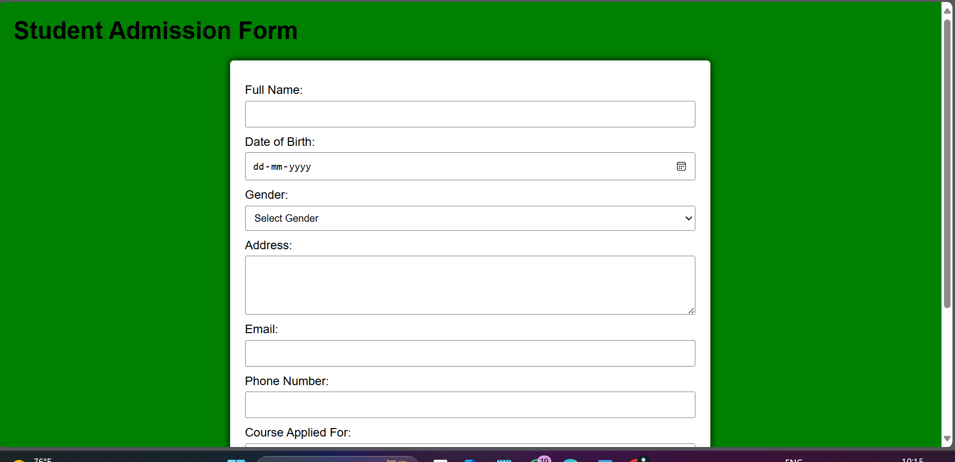



Question-20

Create a proper home page of your own using any components and styles.

Input:

<html>

<head>

<title>My Homepage</title>

<style>

body {

font-family: Arial;

margin: 0;

padding: 0;

background-color:White;

}

header {

background:White;

color: white;

padding: 10px 0;

text-align: center;

}

nav {

margin: 0;

padding: 10px 0;

}

nav a {

color: white;

margin: 0 15px;

text-decoration: none;

font-weight: bold;

}

nav a:hover {

text-decoration: underline;

}

.hero {

height: 400px;

display: flex;

align-items: center;

justify-content: center;

color: white;

text-shadow: 2px 2px 4px;

}

.hero h1 {

font-size: 3em;

}

.container {

padding: 20px;

}

.section {

margin: 20px 0;

padding: 20px;

background: white;

border-radius: 5px;

box-shadow: 0 0 10px;

}

footer {

background: Red;

color: white;

text-align: center;

padding: 10px 0;

position: relative;

bottom: 0;

width: 100%;

}

</style>

</head>

<body>

<header>

<h1>Welcome to My Homepage</h1>

<nav>

<a href="#about">About</a>

<a href="#services">Services</a>

<a href="#contact">Contact</a>

</nav>

</header>

<div class="hero">

<h1>Your Journey Begins Here</h1>

</div>

<div class="container">

<div id="about" class="section">

<h2>About Me</h2>

<p>Hello! I am a web developer with a passion for creating beautiful and functional websites. I love coding and constantly learning new technologies.</p>

</div>

<div id="services" class="section">

<h2>Services</h2>

<ul>

<li>Web Development</li>

<li>UI/UX Design</li>

<li>SEO Optimization</li>

<li>Content Creation</li>

</ul>

</div>

<div id="contact" class="section">

<h2>Contact Me</h2>

<p>If you would like to get in touch, feel free to reach out via email at <a href="mailto:example@example.com">example@example.com</a>.</p>

</div>

</div>

<footer>

<p>&copy; 2024 My Homepage. All rights reserved.</p>

</footer>

</body>

</html>

Output:

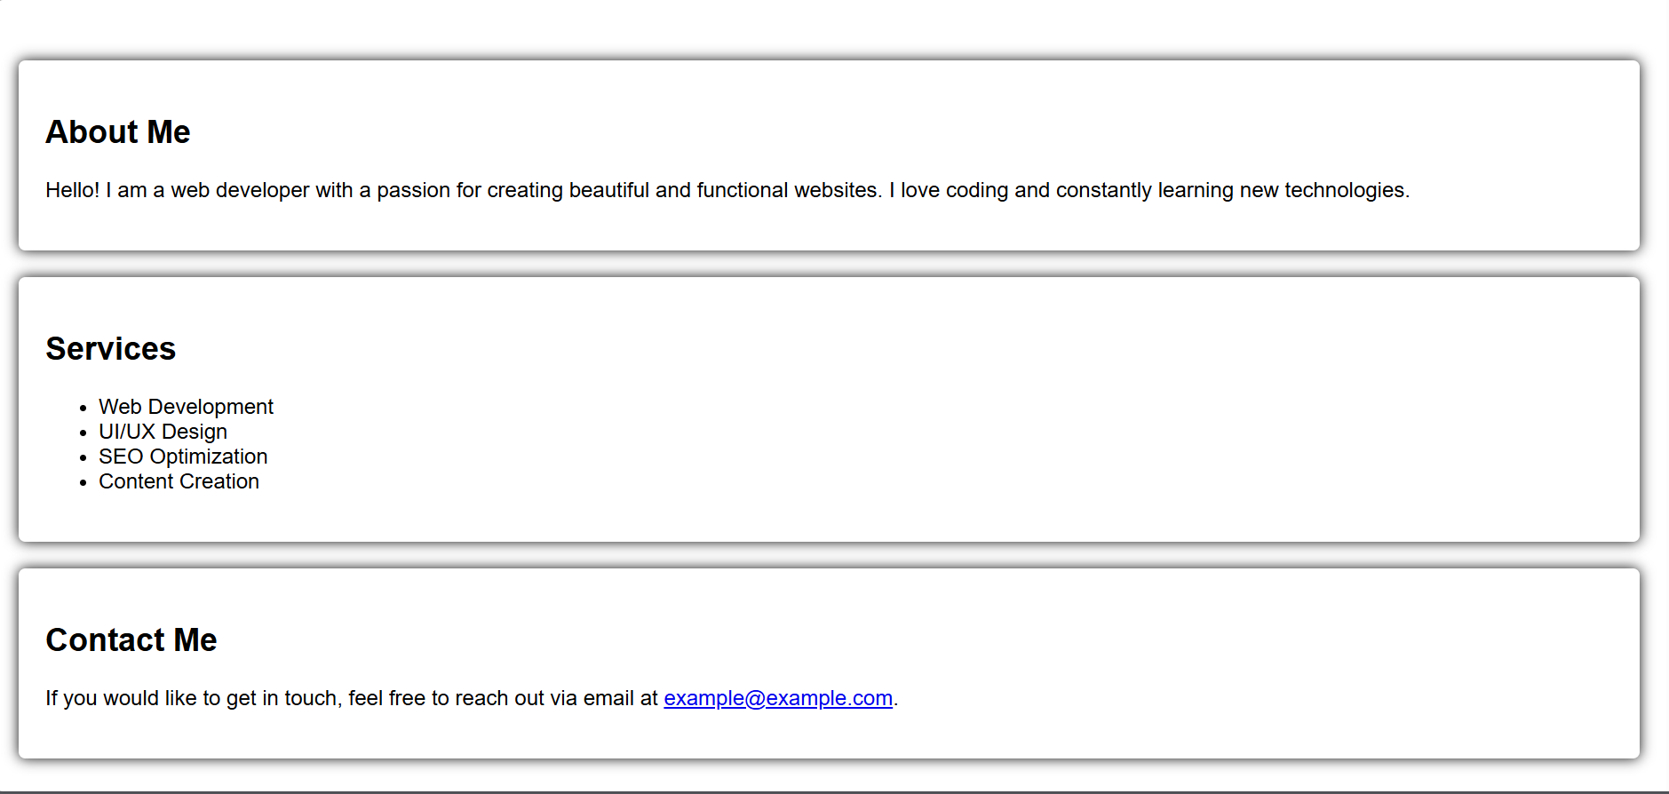

Question-21

Write HTML code for including Local hyperlinking in a web page.

Input:

<html>

<head>

<title>Local Hyperlinking Example</title>

<style>

body {

font-family: Arial, sans-serif;

margin: 20px;

}

section {

margin-bottom: 40px;

}

</style>

</head>

<body>

<h1>Local Hyperlinking Example</h1>

<ul>

<li><a href="#section1">Go to Section 1</a></li>

<li><a href="#section2">Go to Section 2</a></li>

<li><a href="#section3">Go to Section 3</a></li>

</ul>

<section id="section1">

<h2>Section 1</h2>

<p>This is the content of section 1.</p>

<a href="#top">Back to Top</a>

</section>

<section id="section2">

<h2>Section 2</h2>

<p>This is the content of section 2.</p>

<a href="#top">Back to Top</a>

</section>

<section id="section3">

<h2>Section 3</h2>

<p>This is the content of section 3.</p>

<a href="#top">Back to Top</a>

</section>

</body>

</html>

Output:

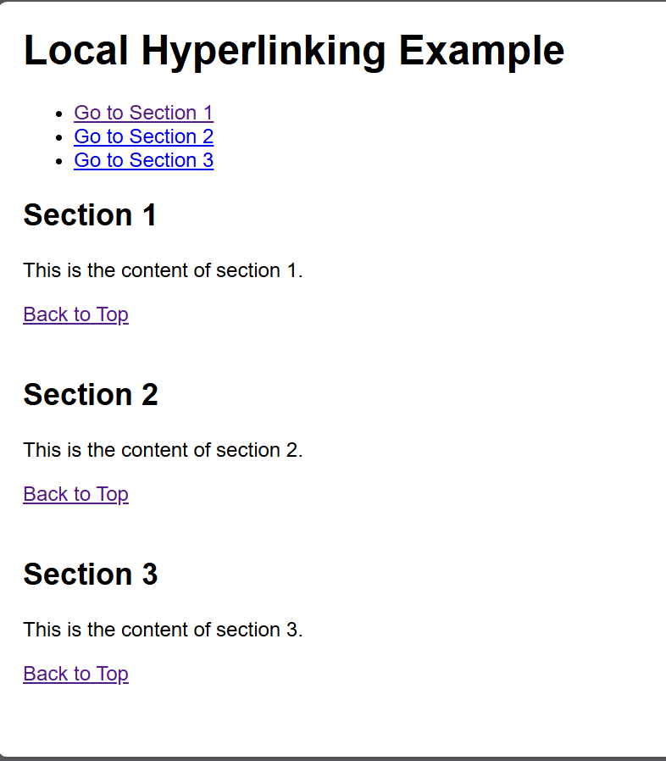

Question-22

Write HTML code for including Inter hyperlinking in a web page.

Input:

<html>

<head>

<title>Interlinking Example</title>

<style>

body {

font-family: Arial, sans-serif;

}

section {

margin: 20px 0;

}

nav {

margin-bottom: 20px;

}

</style>

</head>

<body>

<nav>

<ul>

<li><a href="#section1">Go to Section 1</a></li>

<li><a href="#section2">Go to Section 2</a></li>

<li><a href="#section3">Go to Section 3</a></li>

</ul>

</nav>

<section id="section1">

<h2>Section 1</h2>

<p>This is the first section of the page. You can link to other sections using the navigation above.</p>

<a href="#top">Back to Top</a>

</section>

<section id="section2">

<h2>Section 2</h2>

<p>This is the second section. Use the navigation to jump to other sections.</p>

<a href="#top">Back to Top</a>

</section>

<section id="section3">

<h2>Section 3</h2>

<p>This is the third section. Don't forget to check out the other sections!</p>

<a href="#top">Back to Top</a>

</section>

<a id="top"></a>

</body>

</html>

Output:

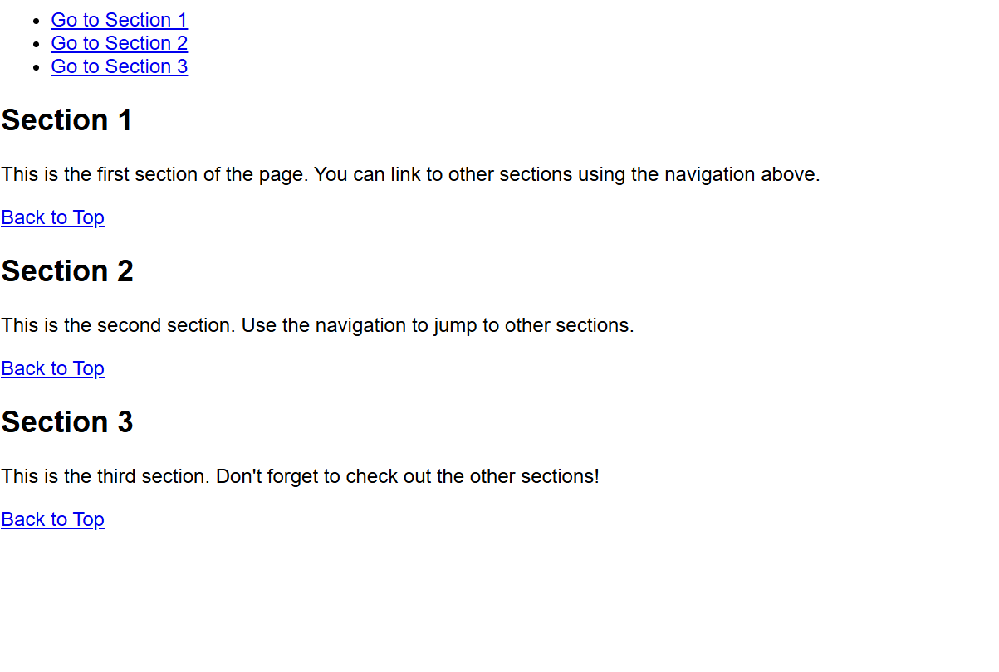

Question-23

Write HTML code for including External hyperlinking in a web page.

Input:

<html>

<head>

<title>External Hyperlinking Example</title>

<style>

body {

font-family: Arial, sans-serif;

}

a {

color: blue;

text-decoration: none;

}

a:hover {

text-decoration: underline;

}

</style>

</head>

<body>

<h1>Welcome to My Web Page</h1>

<p>Here are some useful external links:</p>

<ul>

<li><a href="https://www.wikipedia.org" target="_blank" rel="noopener noreferrer">Visit Wikipedia</a> - A free online encyclopedia.</li>

<li><a href="https://www.github.com" target="_blank" rel="noopener noreferrer">Check out GitHub</a> - A platform for version control and collaboration.</li>

<li><a href="https://www.openai.com" target="_blank" rel="noopener noreferrer">Learn about OpenAI</a> - An AI research organization.</li>

</ul>

<p>Feel free to explore the links above!</p>

</body>

</html>

Output:

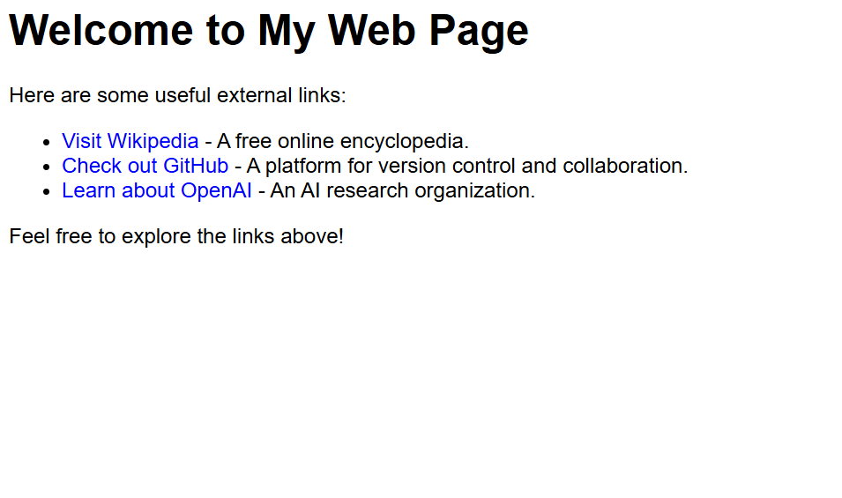

Question-24

Write code to show External CSS with HTML code.

Input:

<html>

<head>

<title>External CSS Example</title>

<link rel="stylesheet" href="styles.css"> <!-- Linking external CSS -->

</head>

<body>

<style>

body {

background-color: #f0f0f0;

font-family: Arial, sans-serif;

}

h1 {

color: #333;

text-align: center;

}

p {

color: #555;

font-size: 18px;

padding: 20px;

}

</style>

<h1>Welcome to My Website</h1>

<p>This is a simple example of using external CSS with HTML.</p>

</body>

</html>

Output:

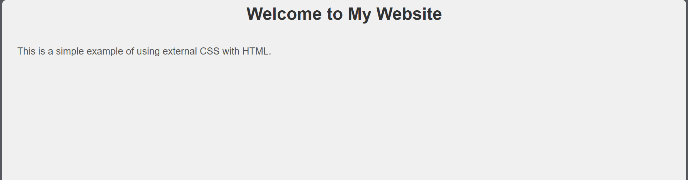

Question-25

Write code to show Internal CSS with HTML code.

Input:

<html>

<head>

<title>Internal CSS Example</title>

<style>

body {

background-color:Wite;

font-family: Arial, sans-serif;

}

h1 {

color:Red;

text-align: center;

}

p {

color:Blue;

font-size: 18px;

padding: 20px;

}

</style>

</head>

<body>

<h1>Welcome to My Website</h1>

<p>This is a simple example of using internal CSS with HTML.</p>

</body>

</html>

Output:

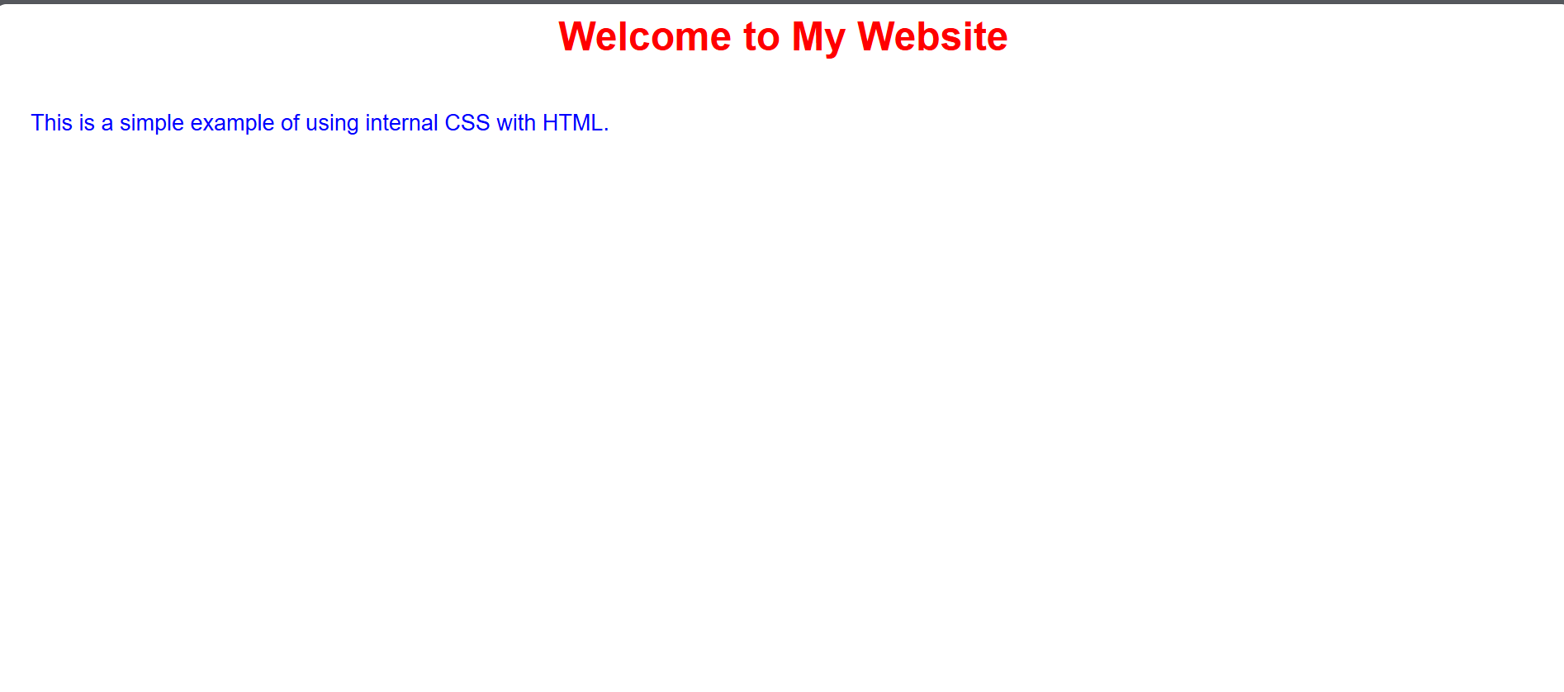

Question-26

Write code to show Inline CSS with HTML code.

Input:

<html>

<head>

<title>Inline CSS Example</title>

</head>

<body style="background-color: Black; font-family: Arial, sans-serif;">

<h1 style="color:White; text-align: center;">Welcome to My Website</h1>

<p style="color: White; font-size: 25px; padding: 30px;">

This is a simple example of using inline CSS with HTML.

</p>

</body>

</html>

Output:

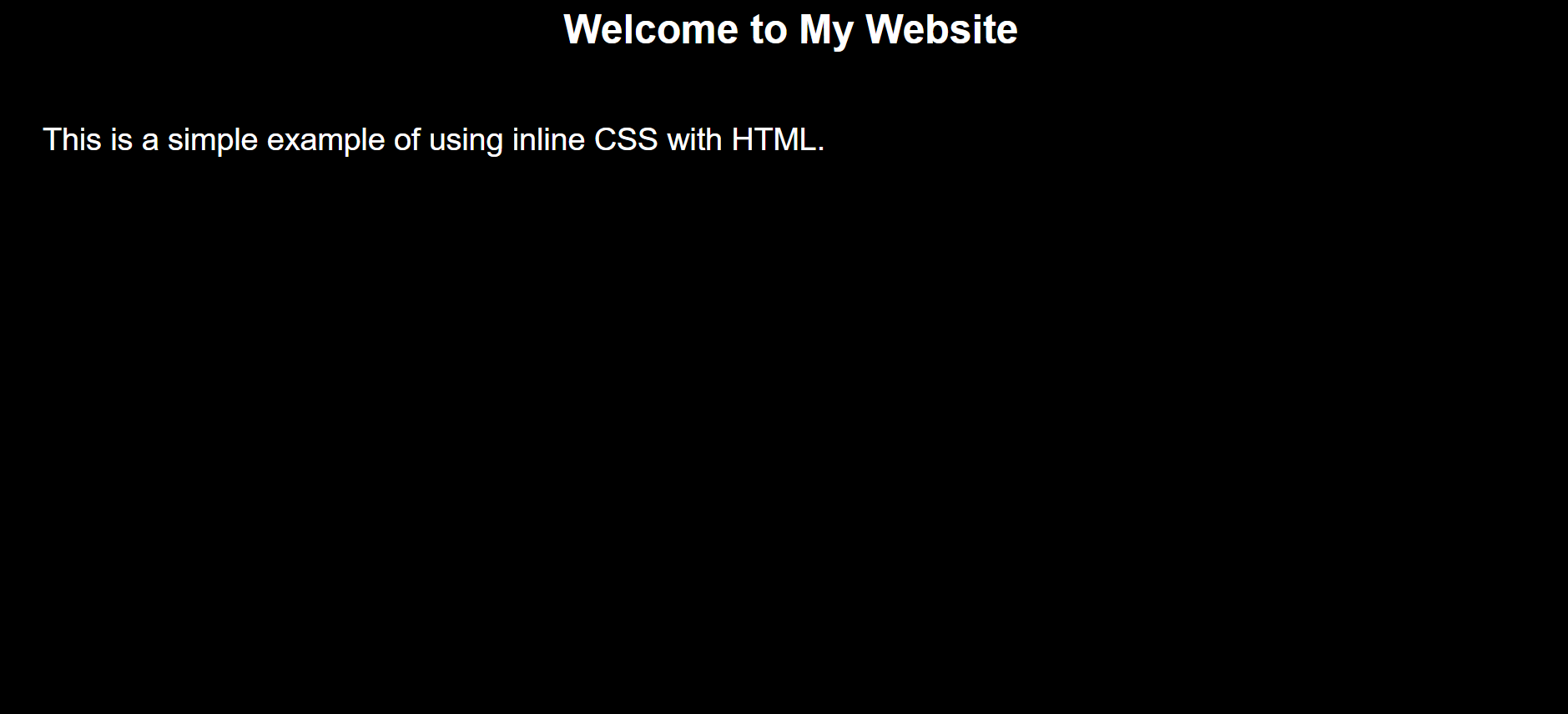

Question-27

Write a program to add two numbers using form in JavaScript.

**Input:**

<html>

<head>

<title>Add Two Numbers</title>

<script>

function addNumbers() {

var num1 = parseFloat(document.getElementById('num1').value);

var num2 = parseFloat(document.getElementById('num2').value);

if (isNaN(num1) || isNaN(num2)) {

alert("Please enter valid numbers.");

} else {

var sum = num1 + num2;

document.getElementById('result').innerHTML = "Result: " + sum;

}

}

</script>

</head>

<body>

<h1>Simple Addition Form</h1>

<!-- Form to input two numbers -->

<form onsubmit="event.preventDefault(); addNumber

<label for="num1">Number 1:</label>

<input type="number" id="num1" required><br><br>

<label for="num2">Number 2:</label>

<input type="number" id="num2" required><br><br>

<button type="submit">Add Numbers</button>

</form>

<div id="result"></div>

</body>

</html>

Output:

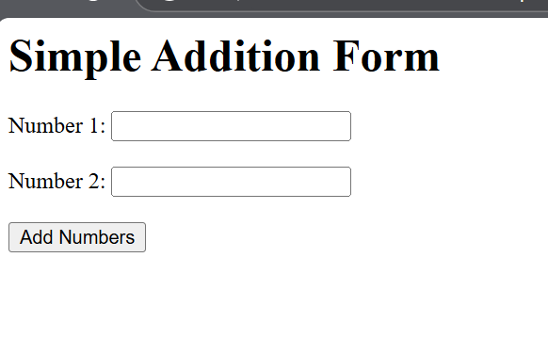

Question-28

Write a program in JavaScript to swap two images using on mouseover event.

Input:

<html>

<head>

<title>Swap Images on Mouseover</title>

<style>

img {

width: 300px; /* Set a fixed size for the images */

height: auto;

cursor: pointer;

transition: all 0.3s ease;

}

</style>

<script>

function swapImages() {

var image1 = document.getElementById('image1');

var image2 = document.getElementById('image2');

var tempSrc = image1.src;

image1.src = image2.src;

image2.src = tempSrc;

}

</script>

</head>

<body>

<h1>Swap Images on Mouseover</h1>

<img id="image1" src="https://via.placeholder.com/300x200.png?text=Image+1" alt="Image 1" onmouseover="swapImages()" />

<img id="image2" src="https://via.placeholder.com/300x200.png?text=Image+2" alt="Image 2" />

<p>Hover over the first image to swap them.</p>

</body>

</html>

Output:

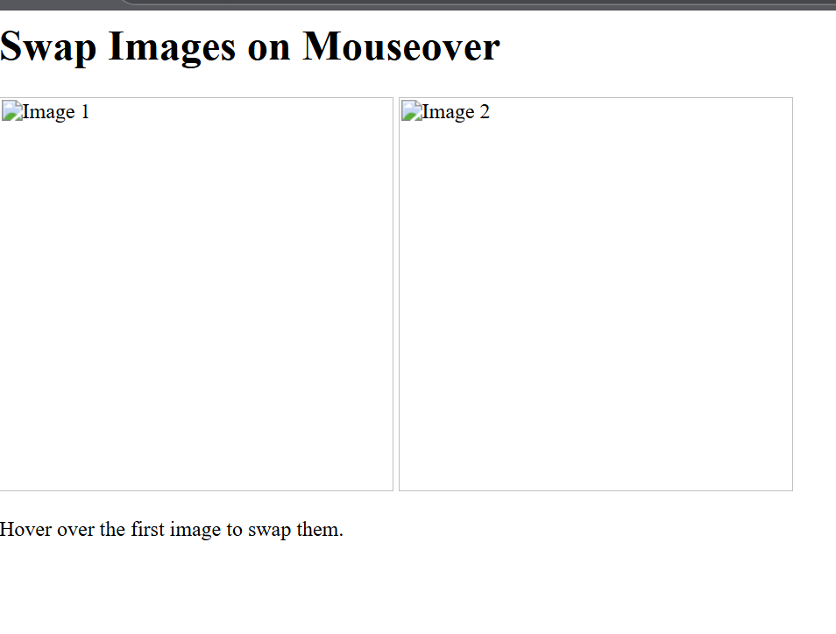

Question-29

Write a simple JavaScript program to sort an array

Input:

<html>

<head>

<title>Sort an Array in JavaScript</title>

<script>

function sortArray() {

var arr = [5, 3, 8, 1, 2, 7];

arr.sort(function(a, b) {

return a - b;

document.getElementById('result').innerHTML = "Sorted Array: " + arr;

}

</script>

</head>

<body>

<h1>Sort an Array in JavaScript</h1>

<button onclick="sortArray()">Sort Array</button>

<p id="result"></p>

</body>

</html>

Output:

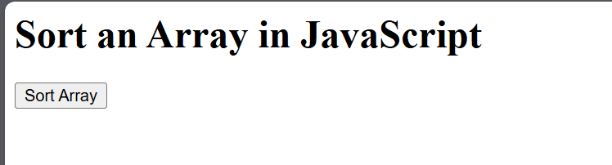

Question-30

Write a JavaScript program to take as input three numbers from the user. Find the minimum and maximum of the three numbers. Print the following output in BOLD in the following format:

MINIMUM =        MAXIMUM =

Input:

<html>

<head>

<title>Find Minimum and Maximum</title>

<script>

function findMinMax() {

var num1 = parseFloat(document.getElementById('num1').value);

var num2 = parseFloat(document.getElementById('num2').value);

var num3 = parseFloat(document.getElementById('num3').value);

var min = Math.min(num1, num2, num3);

var max = Math.max(num1, num2, num3);

document.getElementById('minOutput').innerHTML = "<b>MINIMUM = " + min + "</b>";

document.getElementById('maxOutput').innerHTML = "<b>MAXIMUM = " + max + "</b>";

}

</script>

</head>

<body>

<h1>Find Minimum and Maximum of Three Numbers</h1>

<label for="num1">Enter first number:</label>

<input type="number" id="num1" required><br><br>

<label for="num2">Enter second number:</label>

<input type="number" id="num2" required><br><br>

<label for="num3">Enter third number:</label>

<input type="number" id="num3" required><br><br>

<button onclick="findMinMax()">Find Min and Max</button>

<p id="minOutput"></p>

<p id="maxOutput"></p>

</body>

</html>

Output:

